# **Introduction**

Business analysis is a research discipline that helps us target business problems and the optimal solutions which respond to the business need. These solutions can be about technology, the organisation's business , sales strategy or development policy. The general management of the bank, concerned about the experience of its customers who often complain about the fact that some transactions were made on their credit card without their authorization, and also about the new newspapers that keep saying that the bank does nothing to secure the money of the customers, contacted us to help them solve this problem of fraud that decreases the confidence of customers in their system.

# **Context**

This project was written as part of the business analysis course at ayiti Analytics. We are asked to do a deep analysis of the bank's data in order to make recommendations that can solve the problem or provide a model for fraudulent transactions

# **Problematic**

**Definition of concepts**

**Merchant:** A person or company involved in wholesale trade, especially one dealing with foreign countries or supplying merchandise to a particular trade**.**

**Fraud:** wrongful or criminal deception intended to result in financial or personal gain.

**Customer :** A person or organization that buys goods or services from a store or business

The problem of the bank is that it wants to strengthen the quality of service given to its customers following complaints and regular reports from customers and newspapers about frauds concerning their credit card. So, the questions that arise are: What variables are susceptible to fraud and how can the bank's credit card system be made more secure?

# **Research the organization**

* + - **The Bank ‘s objectif**

The aim of the bank is to maximize his proﬁt and provide higher quality customer service to protect customers financial assets.

* + - **The Bank interaction**

The Bank organization has relationships with customers, employees and the media

* + - **Measure of success**

The bank measures its success by customer loyalty and trust, by increasing the number of customers and profits.

# **Client**

* + - **What are your client's motivations?**

My client wants to increase customer confidence in the bank and solve the problem of fraud in the bank.

# **How does the client measure success?**

My client measures success by increasing the number of customers, retaining customers and providing quality service to the customer.

# **Other revelants stockholder**

* + - **Who are the relevant stakeholders?**

The relevant stakeholders are the board of directors , the management director, the customers, and the media.

# **What authority or power does each stakeholder have?**

* + - * customers can close their credit card account in the bank.
      * The media can spread the news and insist that the public no longer trust the bank.
      * the bank's general manager supervises and validates transactions.

# **CONCEPTUAL MODEL**

* + - **Who are the stakeholders impacted by the problem?**

The stakeholders affected by this problem are:

* + - * Customers lose their money
      * The Bank is losing the trust and loyalty of its customers
      * The board of directors is impacted by a decrease in profit

# **Relationship between the stakeholder:**



* **Bank:** the bank is the institution led by the senior management and works thanks to the customer.
* **Senior management:** senior management directs and coordinates the bank's actions
* **customers:** purchase the bank's services
* **Media:** the media is there to control and publicize the bank's actions towards the customers and vice versa.
  + - **Why is this problem important to the organization?.**

In the world of finance, when a company is negligent in the security of customer funds, it loses the confidence of the customers. So the problem is important for the bank because it can lead to the loss of its customers.

# **Methodology**

To realize this work, we used the data given to us by the bank. Then we did the processing and analysis of the data using python (pandas, numpy, spicy, seaborn, matplotlib). We looked at transactions by gender, category and merchant to see if there was one group more likely to be defrauded than another

**6. Results**

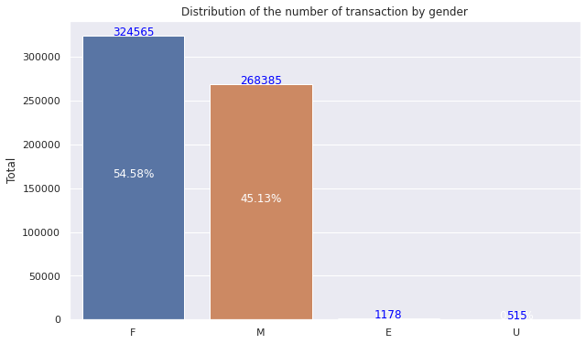

This graph shows the distribution of the transactions by gender. The percentage per woman is 54.58% of the transaction. It's higher than the middle. It's relevant because we can notice that women use their credit cards more than men.

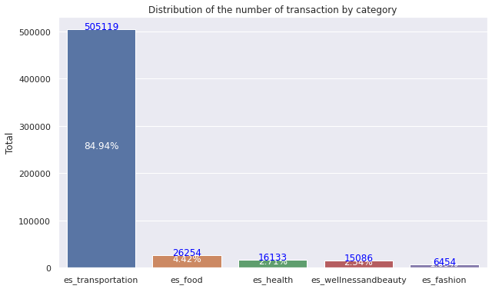

This graph shows the distribution of the transactions by category. The general trend is that 84.9449% of the transactions are made in transport.

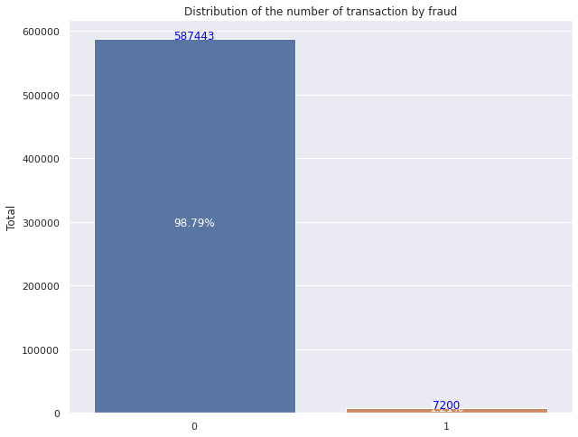

This graph shows the distribution of the transaction by fraud. As we can notice, the frequency of fraud is 1.2% that represents 7200 transactions.

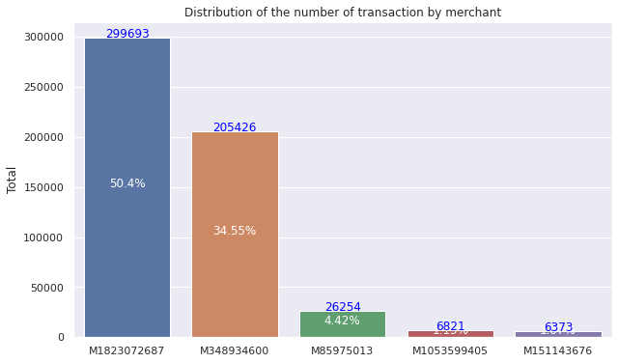

This graph shows the distribution of the transactions by merchant. As we can notice, the frequency of the merchant "M1823072687" is 50.39% and the merchant "M348934600" represents 34.54% of the transactions. We can conclude that more than 84% of the transactions have been registered by these merchants.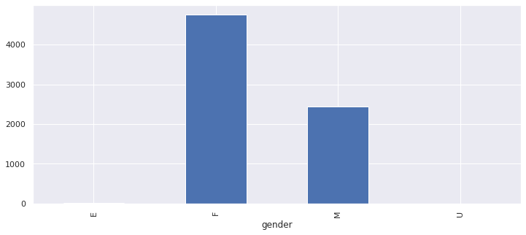

Women are most susceptible to be victims of fraud. On each 1000 transactions made by a female, 14.6 are fraudulent.

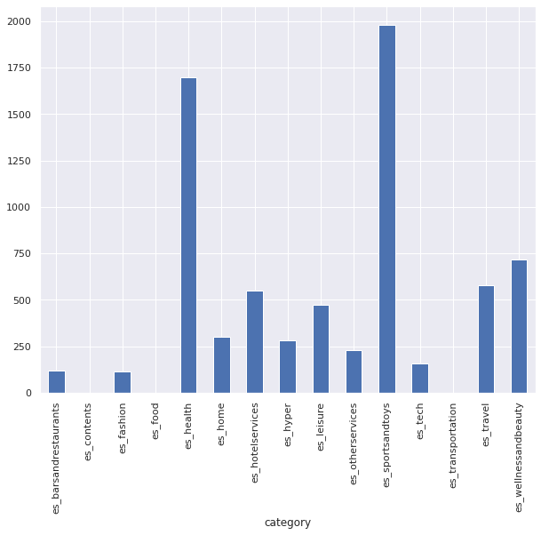

Leisure is the category which is the most susceptible to be a victim of fraud. On each 100 transactions made by a female, 94.99 are fraudulent.

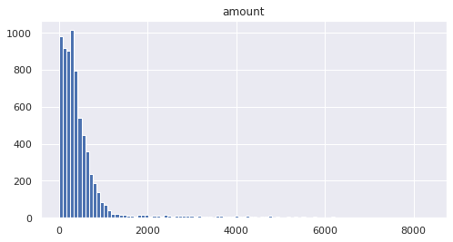

The data shows that there are more than 6000 amounts that are fraudulent between 0 and 2000 $.

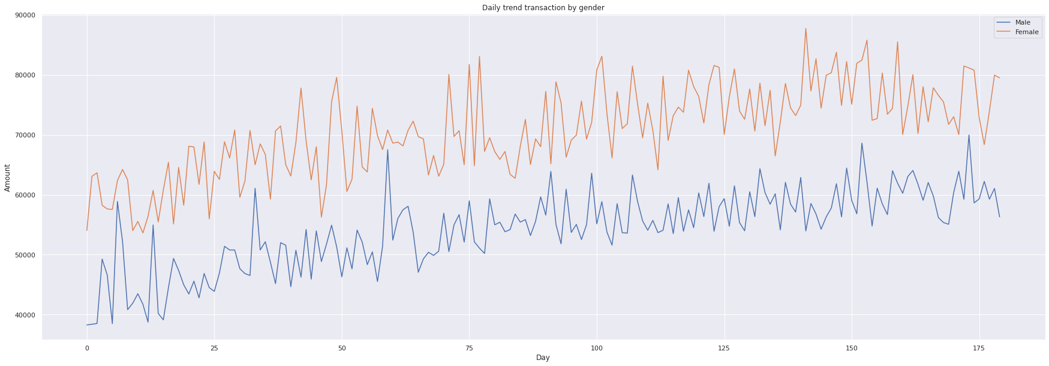

The data show that women tend to purchase more than men. The trend is increasing for the two genders. None of them seem to reduce their purchases for the whole time.

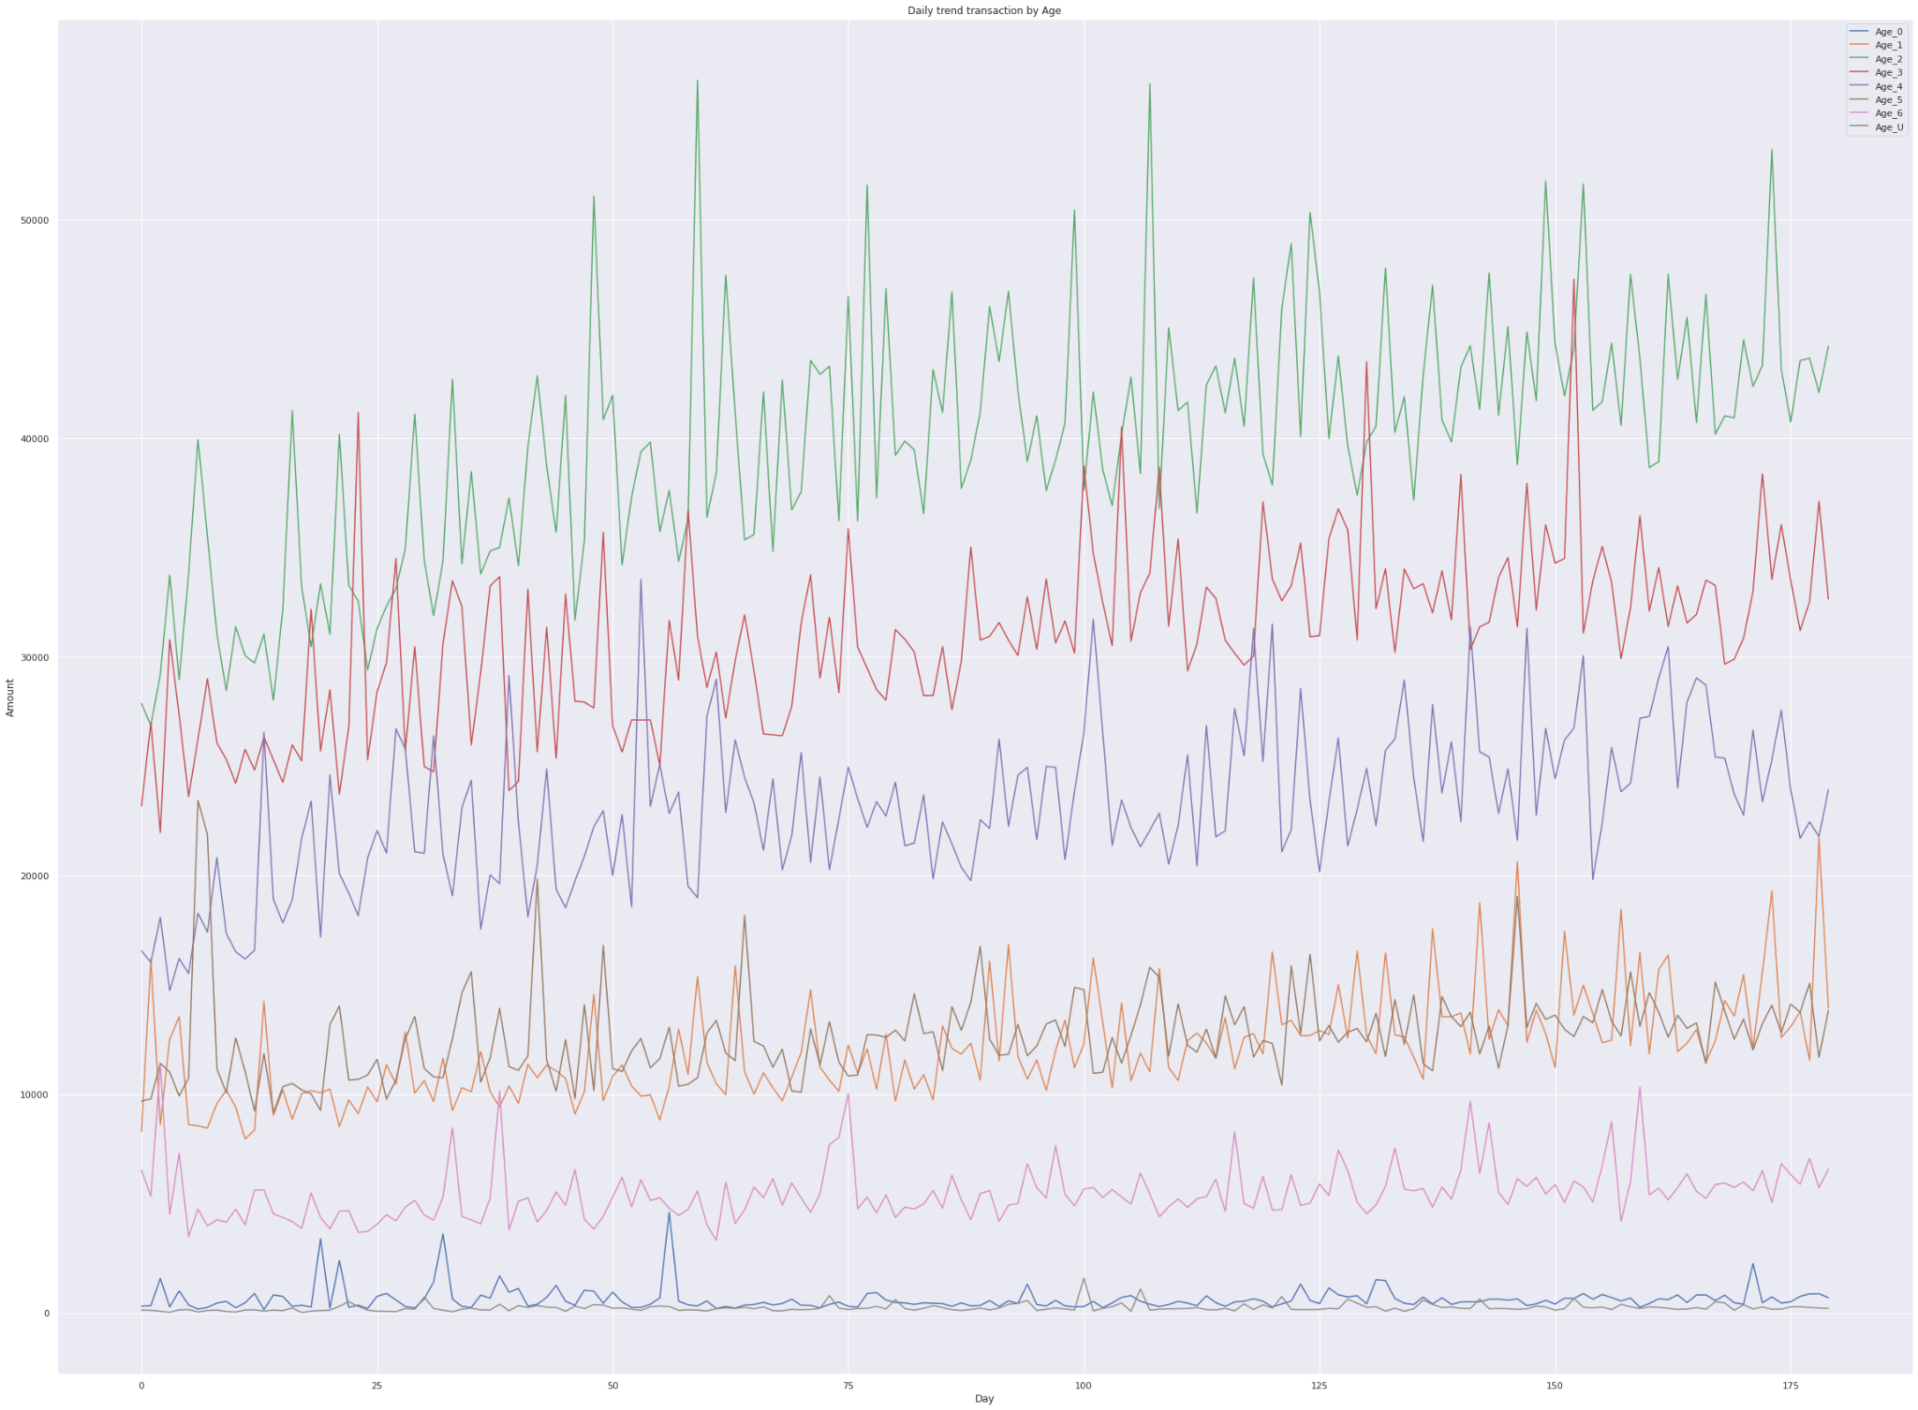

This graph shows that the credit cards that have 2 years and 3 years of use are more susceptible to be victims of fraud.

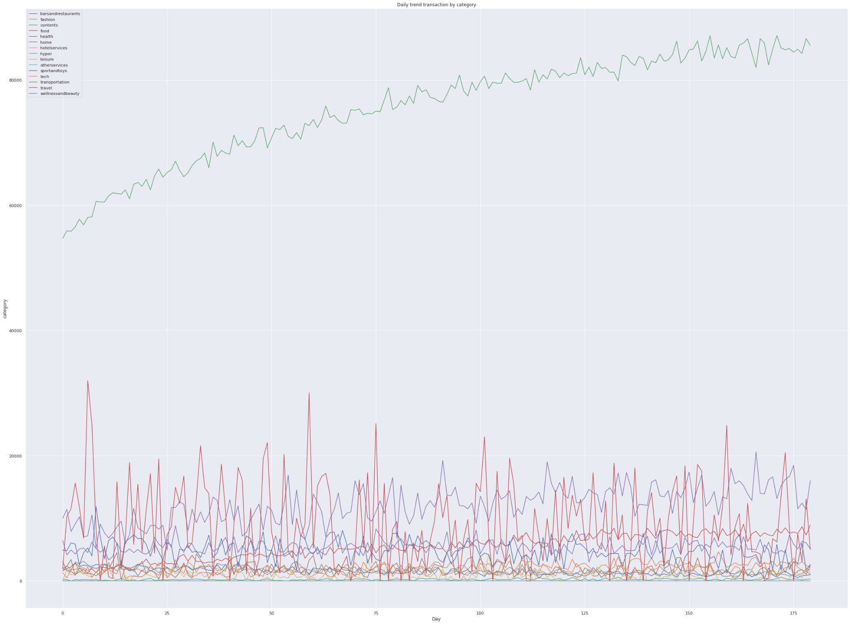

As we can see the daily trend for transport is growing and it is higher than any other in amount. It's increasing. That means there are too many transactions in these categories.

# **Measures of Performance: How do the client, organization and other stakeholders measure the Business Problem?**

They think the problem is really serious because customers are losing their money and the media is giving them free bad publicity.

# **SWOT Analysis**

* + - **Strength**
* Possession of information on the transactions
* strong interest of the bank to provide quality service to the customer
* **Weakness**
* Low level of transaction security
* Negligence towards the complaints

# **Opportunities**

* The bank can regain customer confidence
* The bank can better know the services and merchants likely to commit fraud

# **Threats**

* The Bank is subject to bankruptcy if the situation continues

# **Alternatives solutions**

Considering the amount of credit card fraud, the bank can make some alternative decisions in order to protect the customers:

* Implementation of a more reliable security system for credit cards.
* Educate customers to be careful when using their cards

**Need more data !!!**

The Transportation category doesn’t reflect the reality

suggested by the empirical probabilities. More data would

adjust the distribution to the theoretical probabilities.

There is only one zip code for Merchants as well as for

Clients in the dataset, whereas a bank maintains relations

with people and businesses anywhere. More data on other

locations would also help better the mode check, trigger alerts and automatically block transactions crossing beyond the thresholds (1000$, women, and transportation).

# **Recommendation**

* **Set up a system to help customers control their accounts and identify merchants with a high percentage of fraud.**

The results showed that the frauds are more in the area of transportation and in relation to a certain gender. Therefore, this application with continuous updates can help customers to be more informed.

# **Report as fraud all transactions that follow the trend of fraudulent transactions and wait for the customer's opinion before authorizing the transaction.**

According to the data, the profiles that are the most victims of fraud are female and spend more than 2000 dollars in the leisure industry.

* **A validation code before each transaction that must be made on the card.**
* **Receiving a message from the bank either by mail or by phone every time the customer is going to make a suspicious transaction**